**Creative thinking challenge sheet- sheet-6**

**Dr. Hatem abdelkader 2022**



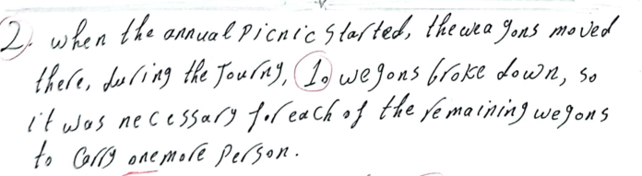





----------------------------------------------------------------------------------------------------------------

Two siblings attend the same school. On the trip to school from home, the sister walks twice

as fast as the brother does and leaves 6 minutes later.

A. Is it possible to determine at what time they meet? If so, find it. If not, explain why not.

B. Is it possible to determine the distance at which the brother and sister meet? If so, find it.

If not explain why not.

Now, the two siblings attend different schools. The sister’s school is 1 mile farther from

home than brother’s, and she takes 50 minutes to get home while he only takes 30. If they are

both walking at the same speed, find the distance to each school and the speed they are

walking

Two siblings attend the same school. The brother takes 40 minutes to walk home, while his

sister takes 30 minutes. If they met at the halfway point, how long after he left school did she

start walking home

Two siblings attend the same school. The brother takes 40 minutes to walk home, while his

sister takes 30 minutes. If they arrive home at the same time, what portion of the distance had

he covered when she left school?